**Fast2sms**

|  |  |
| --- | --- |
| **Date** | 06 November 2022 |
| **Team ID** | PNT2022TMID17579 |
| **Project** | Smart Farmer-IoT Enabled Smart Farming Application |

**Step 1:**

Type fast2sms in google and click on the first link

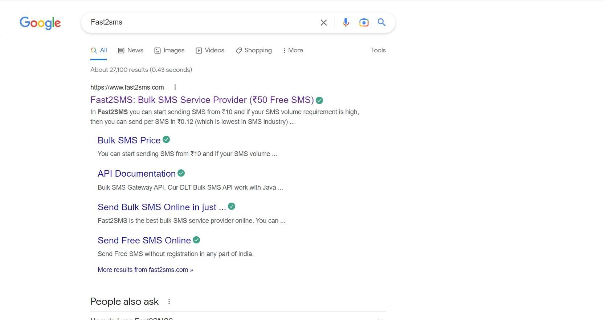

**Step 2:**

click on sign up now

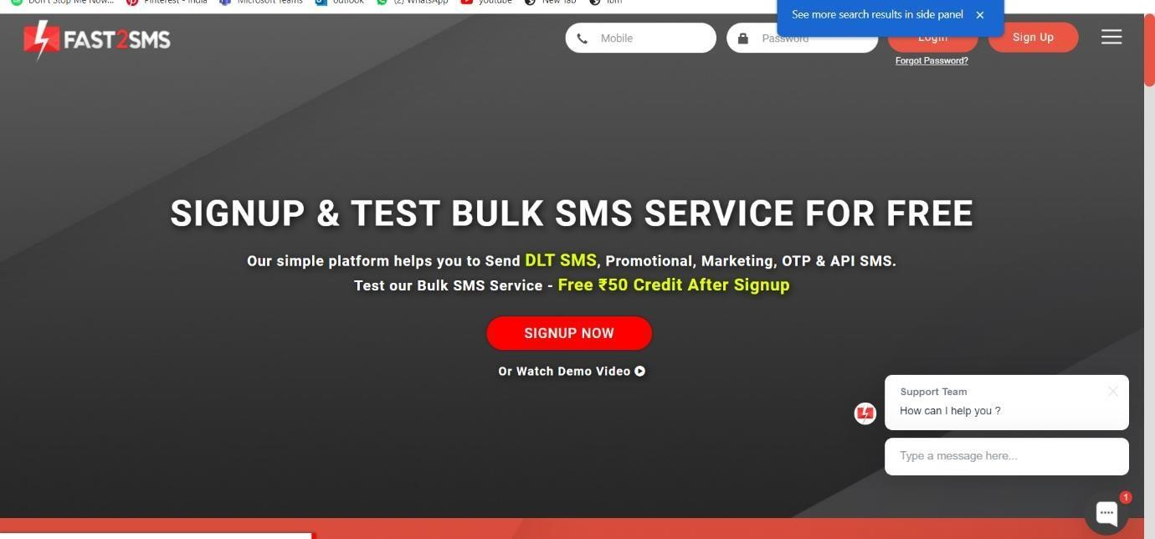

**Step 3:**

Give your details and click on the check box, then click the submit button.

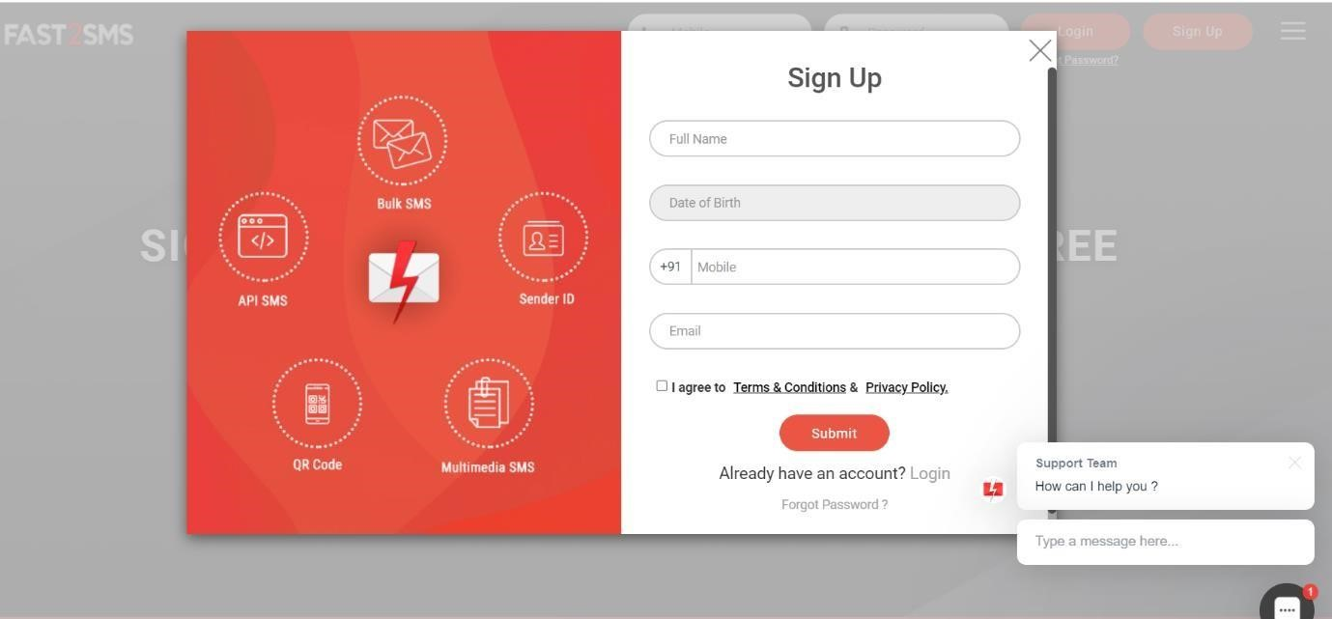

**Step 4:**

You will get the SMS with your password. Type your mobile number and the password then click on the submit button.

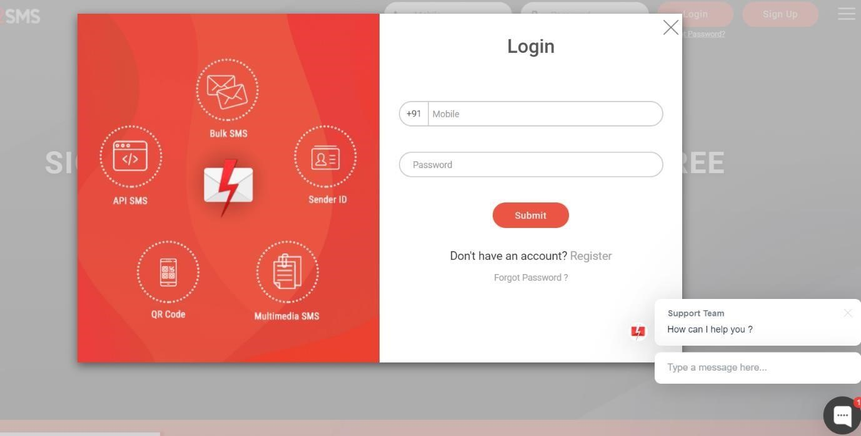

**Step 5:**

Click on the Dev API

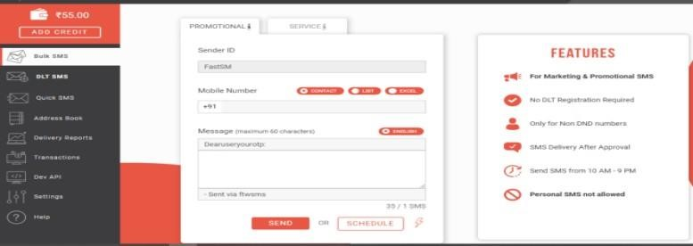

**Step 6:**

Select the Route as Quick SMS and type the message in Message box.

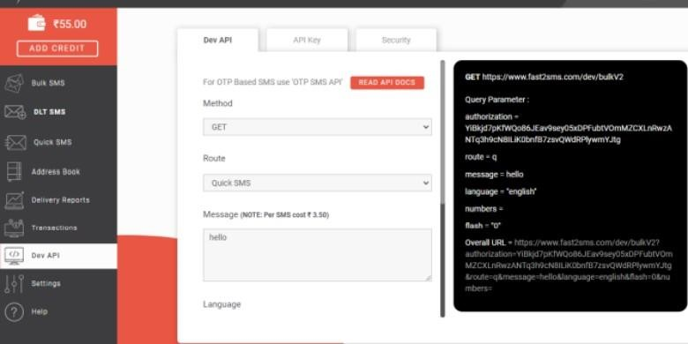

**Step 7:**

Select your language and type your Mobile number in contact

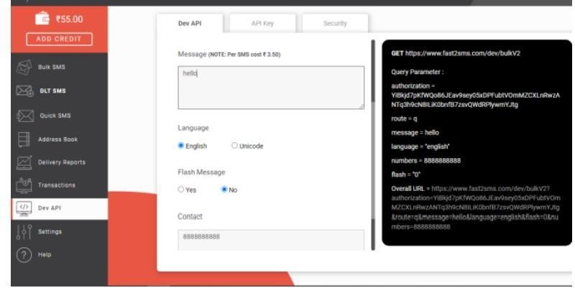

**Step 8:**

Copy the URL and paste it in the new tab

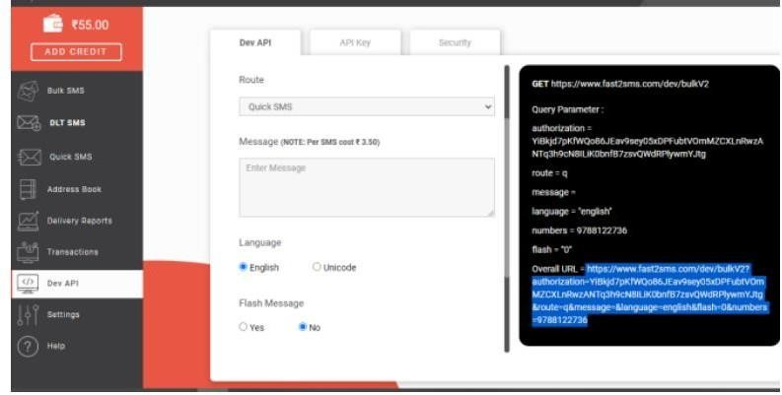

**Step 9:**

